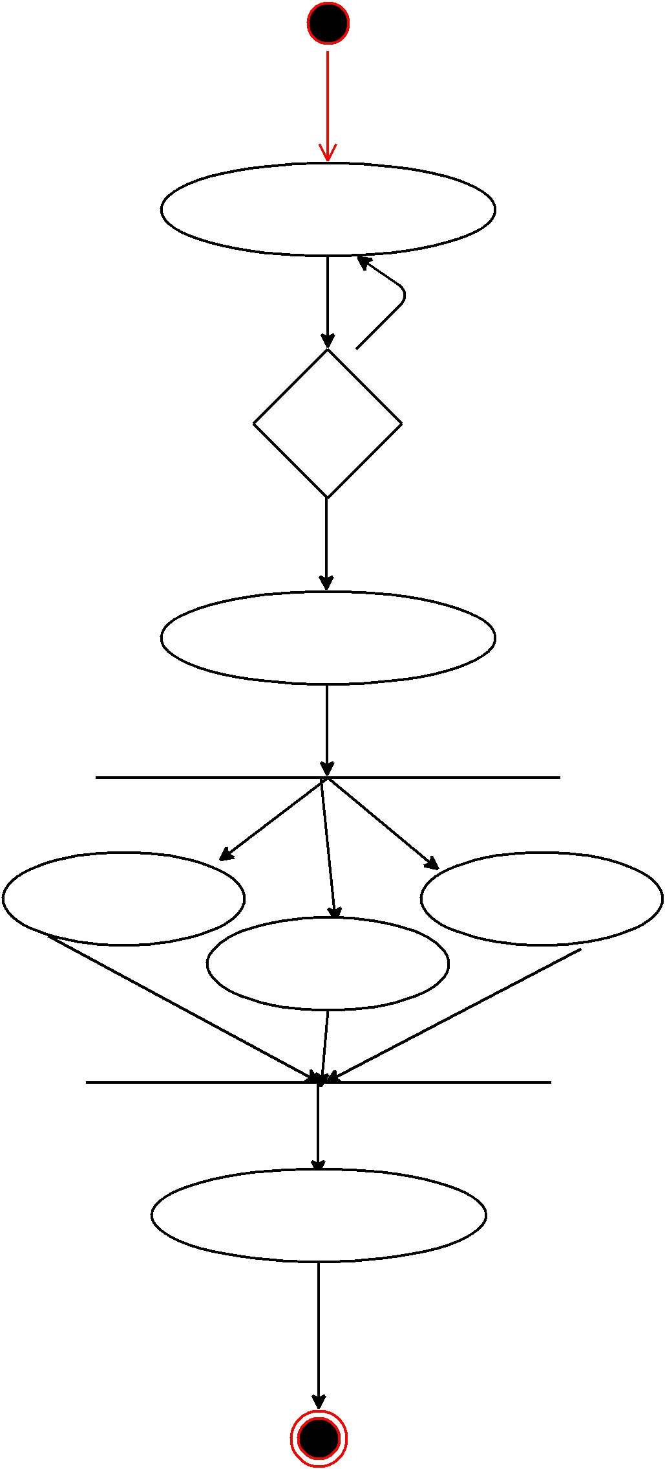

Employee Login

No

Valid

Login

Yes

Choice Menu

Transfer Withdraw

Deposit

Finished

